**SPH3U 6.1 Warmth and Coldness**

1. **Vibrations of atoms and molecules**

|  |  |
| --- | --- |
| Kinetic molecular theory: |  |

|  |  |  |
| --- | --- | --- |
| **Solids** | **Liquids** | **Gases** |
| melting →  ← freezing  ← condensation | boiling → |  |

|  |  |
| --- | --- |
| Thermal energy: |  |
| transfer |  |

1. **Temperature and thermometers**

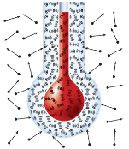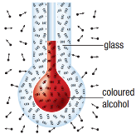

|  |  |
| --- | --- |
| Temperature: |  |
| thermometer |  |

|  |  |  |
| --- | --- | --- |
| **Celsius scale** | **Fahrenheit scale** | **Kelvin scale** |
|  |  |  |

$$T_{C}=T_{K}-273$$

$$T_{K}=T_{C}+273$$

Ethyl alcohol boils at 78.3°C. What is this temperature in kelvins?

Ethyl alcohol freezes at 159 K. What is this temperature in degrees Celsius?

**Homework:** page 274: #1-2, 4